Art Style Guide ***HEAVY REVISION REQUIRED***

1. Basic Back-story

From the GCD:

“There once existed in a tiny pocket dimension not too far from the end of your nose two beings named Posis and Negis. They lived together on either side of what they perceived to be a loop. Posis hated Negis. He was always on the other side of his little loop and Posis just felt that Negis was… different. Horribly different. Posis long ago decided that he, being a logical being, was superior to Negis. Negis meanwhile, was on his side thinking exactly the same thoughts about Posis. So Posis and Negis went to war. Unfortunately, whenever Posis made an attack, Negis would think to do the same attack at the same time and their missiles would collide in midair. Every action that one did, the other perfectly mirrored. So they both independently came up with the same idea at the same time: get outside help. That’s where you come in.”

1. Description of world

The little world that Posis and Negis live in is just a Mobius strip floating in space. A Mobius strip looks like this:

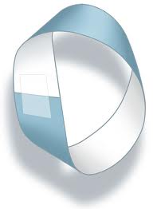

Figure : Mobius Strip

Note the two different colors. In-game, these colors would be black and white representing the two players, and by extension the characters they would be representing.

The feel of the world is predominantly computer driven, and that means filled in wireframe models for the most part, not unlike *Geometry Wars* or *Battlezone.*

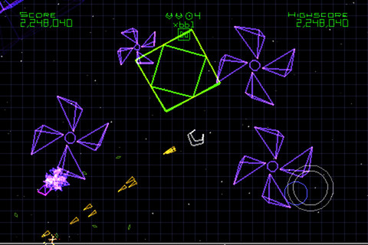

Figure 2: Geometry Wars

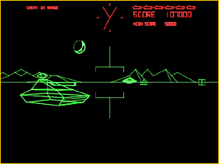

Figure 3: Battlezone

The background color for the skybox is probably going to be a lighter color than pitch black, the rationale of which being that one of the characters, (and the outline for their territory) will be in black.

Posis and Negis:

Posis and Negis are the two main characters in *Mobius*, and their main role is to fight each other. They only appear in a pre-rendered cutscene once at the start of the game, and as 2D images in the corner of the screen.

Posis:

Posis’s name comes from the fact that he represents the positive side of numbers. He is predominantly white with no arms or legs, but does have a pair of floating cubic hands.

The below reference image is of Mono from *Audiosurf*. Posis’s body does not look exactly like Mono, but they share many vague similarities.



Figure 4: Mono

Posis and Negis look *exactly* alike except that Posis is white and Negis is black.

This is a crucial aspect of the game: Posis and Negis are exactly alike in all respects, even their world is symmetrical. The only difference is that Negis represents the negative side of the number line and Posis is the positive side.

The characters

Assets:

Bunker:

The Bunker is a blocky, cubic building used for defense of valuable assets such as the tank and package